Guidance Document

SBP Guidance for US REDIII Level B LULUCF v1.0

Guidance for Biomass Producers undertaking the
Level B risk assessment for RED
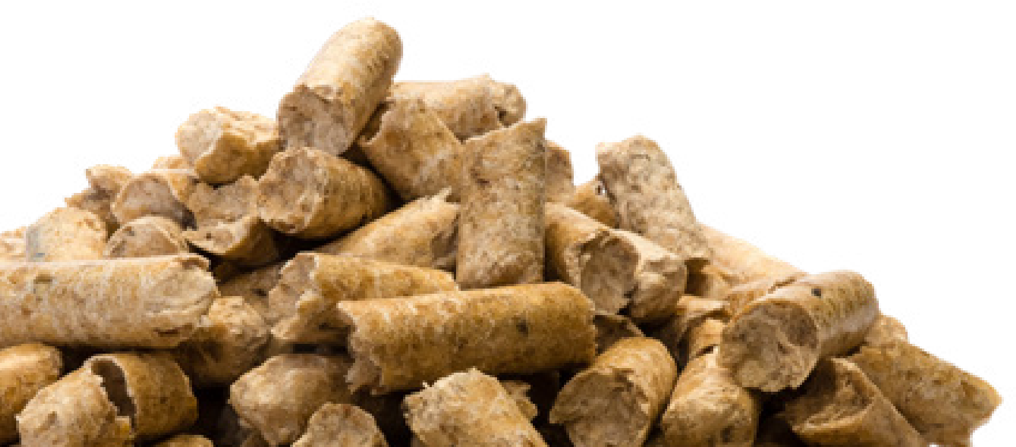
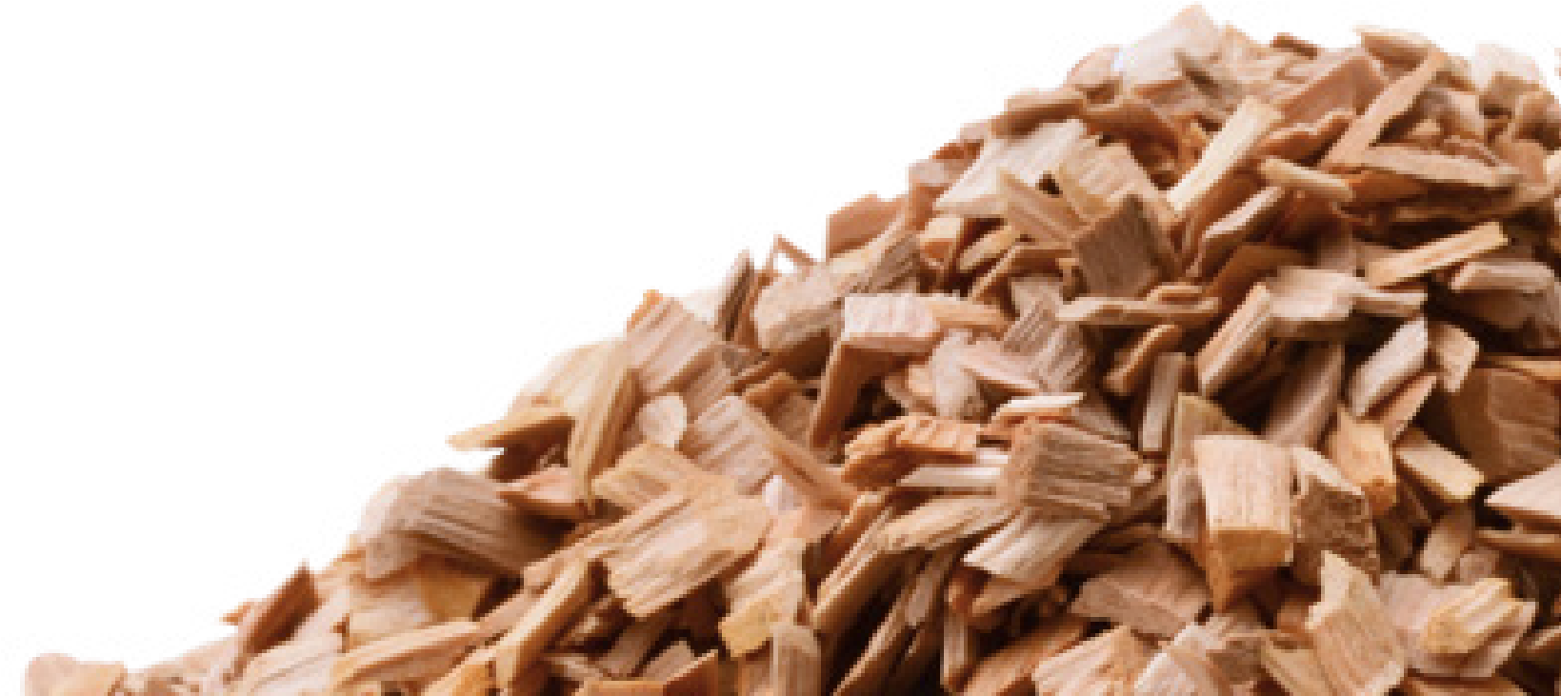
Article 29(7)and
Sustainable Biomass Program
sbp-cert.org
indicator 3.1.1 of the SBP
Standard 1
Version v1.0

Formal status of document: approved by the SBP Technical director
Approval date: | 21 January 2026
Publication date: | 21 January 2026
Effective date: | 27 January 2026

Document history
Version 1.0 | Published 21 January 2026

Table of Contents
Foreword 3
1. Introduction 4
Support in Implementing Level B 5
2. Regional background and statement of scope 7
2.1 Regional Background 7
2.2 Scope 8
3. Level B Risk Assessment Process 10
3.1 Summary 10
3.2 Detailed Instructions for Completing a RED III Level B Risk Assessment 12
4. Results 20
5. Risk Management Plan 23
5.1 Recommended Risk Management Measures 23
Annex I – Methodology 27
Step B.1: Define the spatial boundaries of the compliance check 28
Step B.2: Define relevant carbon pools 30
Step B.3: Determine a historical reference period 30
Step B.4: Quantify carbon stocks and sinks of the sourcing area for the historical reference period 31
Step B.5: Define the length of the future long-term period 32
Step B.6: Describe forest management practices in a sourcing area for the future long-term period 32
Step B.7: Quantify mean carbon stocks and sinks over the future long-term period 32
Step B.8: Compare the future carbon stocks with the historical reference period. 33
Annex II – Guide to the “US RED III Level B LULUCF” Microsoft Excel File 35
References 36

Foreword
The guidance was developed using a rigorous methodology to help producers identify sourcing areas with decreasing carbon stocks, enabling the development of adapted mitigation measures.
Biomass Producers may adapt this Guidance document to suit their specific sourcing areas by using the carbon stock assessment results provided in the accompanying Excel tool. These results can be used to demonstrate compliance with the Level B management system requirements. Use of this Guidance is voluntary, and Biomass Producers may instead develop their own forest carbon stock assessment methods, provided they are consistent with the SBP Instruction Document EU RED v2.0, Section 1.6 and Annex D.
Results of the Risk Assessment as presented in Section 4:
Stable/Increasing
Sub-scope carbon stock classified as Stable/Increasing met at least one of the following criteria:
• The projected carbon stocks for the future long-term period are higher than the average carbon stocks for the historical reference period; or
• The projected carbon stocks for the future long-term period are lower than the average carbon stocks for the historical reference period, but the average projected carbon stock for the future long-term period does not exceed the average calculated Confidence Interval (CI) for the 2010–latest available inventory period.
Implication: Feedstock may be sourced from sourcing areas classified as Stable/Increasing.
Decreasing
Sub-scope carbon stock classified as Decreasing met the following criterion:
• The projected carbon stocks for the future long-term period are lower than the average carbon stocks for the historical reference period, and the average projected carbon stock for the future long-term period exceeds the average calculated CI for the 2010–present period.
Implication: Feedstock may only be sourced where Risk Management Measures demonstrate that carbon stocks are stable or increasing.

1. Introduction

The updated Renewable Energy Directive III (RED III, Directive (EU) 2023/2413) remains a core legal gateway for US industrial pellets to qualify as “renewable” in the EU energy generation. RED III Article 29(7) establishes the land‑use, land‑use change and forestry (LULUCF) rules that must be complied with to consider biomass fuels as renewable, and therefore merchantable to EU energy producers. SBP has incorporated EU RED III requirements into its certification system, making compliance with RED III mandatory for SBP Certificate Holders (CHs).
SBP applies a risk-based approach when assessing sustainability criteria for woody feedstock. Risk assessments take one of two forms: Regional Risk Assessments (RRAs) that are developed by SBP and its working bodies (WB), and Company Risk Assessments (CRAs) that must be developed by Certificate Holders in regions not covered by an RRA.
RRAs apply a comprehensive, structured, and data-driven methodology to identify and assess potential social, environmental, and economic risks associated with biomass feedstock sourced from defined sub-scopes. RRA’s align with the legality and sustainability requirements outlined in SBP Standard 1: Feedstock Compliance. RRA’s have been developed for forest biomass sourced from two specific geographic and administratively defined scopes in the United States (US):
  - National Forests managed by the USDA Forest Service within the Contiguous US (lower 48 states); and,
  - Private lands and non-National Forest public lands (Federal, State and local public or any other tenures) within 16 states located principally in the US Southeast Region.
To further support Biomass Producers transitioning to RED III, SBP created and published the RED III Level
A Risk Assessment to assist in implementing the management systems necessary for compliance with the EU RED sustainability criteria. As an independent document, the RED III Level A Risk Assessments replace the Annex 6 RED II Level A Risk Assessment previously incorporated in the applicable RRA. RED III Level A Risk Assessments have been completed as companion documents for each of these two US-based RRA’s. All of these documents can be accessed on the SBP website.
For forest biomass to be eligible for RED targets established by EU member countries, RED Article 29(7) requires the following:
- The country or regional economic integration organisation of origin for the forest biomass is a Party to the Paris Agreement and
- it has submitted a nationally determined contribution (NDC) to the United Nations Framework Convention on Climate Change (UNFCCC), covering emissions and removals from agriculture, forestry and land use, which ensures that changes in carbon stock associated with biomass harvest are accounted towards the country's commitment to reduce or limit greenhouse gas emissions as specified in the NDC; or
- Has national or sub-national laws in place, in accordance with Article 5 of the Paris Agreement, applicable in the area of harvest, to conserve and enhance carbon stocks and sinks, and providing evidence that reported LULUCF-sector emissions do not exceed removals.
- Where evidence referred to in point (a) of this paragraph is not available, management systems are in place at the forest sourcing area level to ensure that carbon stocks and sink levels in the forest are maintained or strengthened over the long term.
There are two pathways for demonstrating compliance with RED III requirements, termed Level A and Level B:
- Level A. Compliance is demonstrated at the national or sub-national (e.g., state) level by reliance on robust legislation, monitoring, and enforcement that are determined to be sufficient to meet RED III Article 29 forest biomass criteria. When SBP has endorsed a RED III Level A Risk Assessment, Biomass Producers can treat all forest biomass sourced from the corresponding national or sub-national region as meeting the RED III forest‑biomass sustainability criteria.

- Level B. If a RED III Level A Risk Assessment cannot demonstrate low risk through robust legislation monitoring and enforcement, Biomass Producers must demonstrate compliance at the forest sourcing area level, using a risk-based approach and field-level evidence.
These articles are duplicated in SBP Standard 1, indicator 3.1.1, where article (a)(i) corresponds to Route A, article (a)(ii) to Route B, and (b) to Route C, respectively.
On January 20, 2025, the United States (US) President signed an Executive Order directing the United States Ambassador to the United Nations to submit a formal written notification of the United States’ withdrawal from the Paris Agreement. This formal notification was submitted to the United Nations by the US Ambassador to the United Nations on January 26, 2025.
Article 28 of the Paris Agreement stipulates that “withdrawal shall take effect upon expiry of one year from the date of receipt by the Depositary of the notification of withdrawal.” Consequently, as of January 27, 2026, the United States will no longer be a Party to the Paris Agreement, and from this date forward, the REDIII Level A Risk Assessment for article 29 (7) will cease to apply to US feedstock. Therefore, Biomass Producers will be required to conduct a Level B risk assessment specific to their sourcing, requiring that GHG emissions may not exceed removals (i.e., no net emissions).
Critically for US producers, as of January 27, 2026, biomass must be sourced only when management systems are in place at the forest sourcing area level to ensure that carbon stocks and sinks are maintained or strengthened over the long term.

Support in Implementing Level B
To support US-based Biomass Producers, SBP developed this guidance and resources with the support of US experts. US-based Biomass Producers are encouraged to use them to conduct a RED III Level B assessment, noting and recognising that Biomass Producers may also decide to use alternative methodology to demonstrate compliance with this article. This report has been developed to provide guidance and resources for US-based Biomass Producers to conduct a RED III Level B Risk Assessment. Further guidance is available in the following documents:
- European Commission: Directorate-General for Energy, Navigant Netherlands B.V, Oeko-Institut, The European Forest Institute (EFI) and The Institute for European Environmental Policy (IEEP), Technical assistance for the preparation of guidance for the implementation of the new bioenergy sustainability criteria set out in the revised Renewable Energy Directive – REDIIBIO – Final report, Publications Office, 2021, https://data.europa.eu/doi/10.2833/592471
- Sustainable Biomass Program (SBP). SBP ID EU RED v2.0 – Instruction Document EU RED: Bridging Requirements for Meeting the Renewable Energy Directive (EU/2023/2413) Published 16 May 2025.
- Guidance for Standard 1 indicator 3.2.1
This report provides a transparent, conservative approach for evaluating whether forest carbon stocks in the US supply base are stable or increasing. Methodologies presented here are consistent with the guidance contained in the normative part of the SBP ID EU RED (Section 1.6), which articulates the steps for demonstrating compliance under Level B as follows:
- identify the spatial boundaries of the sourcing area for which compliance needs to be demonstrated, for instance by means of geographical coordinates, plots or parcels, including stands and tracts of land, and identify the relevant forest carbon pools, namely:
  - aboveground biomass;
  - belowground biomass;
  - litter;
  - deadwood; and
  - soil organic carbon.

- calculate the average forest carbon stocks and sinks over a historical reference period with the purpose of establishing a benchmark for the comparison of maintenance or strengthening of forest carbon stocks and sinks of a sourcing area. Economic operators shall use the reference period of 2000-2009, or another period of similar length and as close as possible to 2000-2009, to facilitate the use of forest inventory data or to mitigate the impacts of natural disturbances or other extreme events. The economic operators shall duly justify the choice of their reference period. The economic operator shall estimate reference values for all relevant carbon pools individually identified pursuant to point (a).

- describe the scenario of the expected forest management practices in a sourcing area for a projected long-term period covering at least 30 years after the harvesting event from which biomass is sourced. That scenario shall be constructed on the basis of the forest management practices in a sourcing area documented for the historical reference period, or in existing forest management plans or other verifiable evidence.

- estimate the average carbon stocks and sinks of the sourcing area over the projected long-term period, covering at least 30 years depending on the forest growth rate, after the harvesting of the forest biomass. In order to ensure comparability with the historical reference period, those estimates shall use the same carbon pools, data and methods referred to in points (a) and (b). Where economic operators are not able to quantify one or more of the pools identified pursuant to point (a), they shall provide due justification.

- compare the average carbon stock and sinks in the relevant forest sourcing area of the projected long-term period with the forest carbon stocks and sinks of the historical reference period. If the average forest carbon stocks and sinks of the projected long-term period are equal to or higher than the average forest carbon stocks and sinks of the historical reference period, the forest biomass is in compliance with the LULUCF criteria at the forest sourcing area level. Economic operators shall put in place adequate monitoring and verification systems of the actual development of carbon stock and sinks in demonstrated compliance with the requirements set out in this article.
The United States Department of Agriculture (USDA) Forest Service’s Forest Inventory and Analysis (FIA) Program is the US’s official, continuous forest census and the foundational data system underpinning all major federal reporting on US forests. The FIA provides nationwide, plot-based, statistically robust monitoring of forest extent, condition, carbon stocks, and change across all ownerships, using a design that ensures consistent methods across states and enables unbiased national estimates. Because of its rigorous field protocols, transparent methodologies, and long-term continuity, the FIA is recognised as one of the world’s most credible forest inventory systems. FIA data form the core of the US annual greenhouse gas inventory submitted to the United Nations Framework Convention on Climate Change (UNFCCC), including land-sector carbon stock and flux estimates. The same data support the US reporting to the annual Global Forest Resource Assessment (FRA) compiled by the Food and Agriculture Organisation of the United Nations (FAO), where FIA provides the authoritative source for US forest definitions, forest area, growing stock, biomass, and management indicators. With annualised sampling that remeasures a proportion of plots each year, FIA delivers up-to-date, systematically collected information used by policymakers, scientists, land managers, and international reporting bodies to assess the status and trends of US forests.
For these reasons, FIA data and documented definitions serve as the foundation for the information provided in this document.

2. Regional background and statement of scope

2.1 Regional Background
The focus of this assessment is forest lands contained within the lower 48 adjoining US states, commonly referred to as the conterminous US (CONUS). CONUS does not include Alaska (AK) or Hawaii (HI) and is bordered by Canada to the North and Mexico to the South, extending from the Pacific Ocean on the west to the Atlantic Ocean on the east, and the Gulf of Mexico to the southeast.
Figure 1. Map of the United States.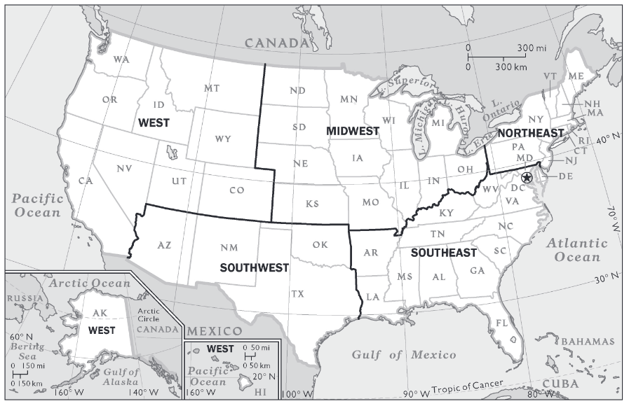
Source: National Geographic
The forest land area of the US (including states outside CONUS) totals 630,383,000 acres (308,895,000 hectares), roughly one-third of the total land area (FRA 2025). US forests span more than forty-six degrees of latitude, resulting in exceptional diversity in forest structure, composition, and function, including temperate moist forests, temperate dry forests, subtropical humid forests, and boreal/subboreal forests.
The majority of forest land in the US is under private ownership (58%), with public ownership comprising the rest (42%). Publicly owned forest land is dominated by federal ownerships (30%), with the majority of those lands owned by the USDA Forest Service (19%), followed by other federal agencies (11%), state forests (9%), and local/municipal (~3%). Ownership patterns vary significantly by region: Western states hold the greatest amount of land under federal ownership, while Eastern states are dominated by private ownership (FRA 2025).
US forests serve as a substantial net carbon sink, absorbing hundreds of millions of metric tons of CO₂ annually and offsetting roughly 10-15% of total US greenhouse gas emissions. Gains in carbon stocks stem primarily from continued growth of existing forests and expansion or improved stocking of planted forests under active management, particularly in the Southeast (Domke et al. 2025). However, carbon losses from a combination of forest disturbances, particularly wildfires, insect or disease outbreaks, and drought-induced mortality, have caused the forests of some states in the US to become carbon sources (i.e., Arizona, Colorado, Idaho, Montana, New Mexico, South Dakota, Utah, Wyoming,). While in total, US forests continue to be a net sink, interannual variation remains significant, and future sink strength will depend heavily on land-use change, disturbance regimes, and forest management (McGinley et al. 2023).

Legal Context
Forest lands in the US fall into two broad categories of ownership: public lands, which are owned by federal, state, county, municipal or other levels of government; and private lands, which are owned by individuals, groups of individuals, or organized corporations. The use of public forest lands is directed by legislation enacted by duly elected public officials, and typically subject to public input. The use of privately owned lands is governed by strong private property rights.
The management of forests in the US is regulated by an overlapping network of federal, state and local laws. All states have also developed best management practices (BMPs) for forest management as required by the federal Clean Water Act. Implementation of BMPs may be voluntary or regulatory, and in all instances have a significant positive influence on forest management operations affecting soil and water quality on non-federal lands. Some states (e.g., WA, OR, CA) have enacted their own forest practices laws regulating harvest, reforestation, water protection, and wildlife protection on private and state lands.

Socio-economic Context
The US is the global leader in both production and consumption of wood products. Driven by planted stands of fast-growing pine species (e.g., loblolly pine) in the Southeast, high-yield conifer systems in the Pacific Northwest, and a robust private ownership base, the US is consistently one of the world’s top producers of industrial roundwood and wood fibre. The national timber industry plays a major role in global wood supply while maintaining forest area and productivity through systematic regeneration and sustainable harvesting practices. This is evidenced by the steadily increasing volume of growing stock in US forests. As reported in the FAO’s 2025 FRA, total forest growing stocks in the US rose from approximately 110 million m³/ha in 1990 to 148 million m³/ha in 2025.
The majority of public land in the lower 48 US states has been acquired by the US federal government through treaties signed with Native American Indian tribes. There are 574 federally recognised tribes in the US. In total, 359 of these tribal entities are located in the lower 48 states (US General Services Administration, 2024). Between 1722 and 1868, 374 treaties with Indian tribes were ratified by the US Congress (US National Archives and Records Administration, 2024). Roughly 60 tribes have retained usufruct rights to lands and resources located outside the reservation boundaries established by treaties. Off-reservation treaty rights include livestock grazing, hunting, fishing, gathering, and water usage rights. Treaties signed by tribes and the US federal government are equivalent to federal law and binding on both parties.

2.2 Scope
The scope of this assessment covers the entire CONUS supply base and includes all unreserved forest land in the lower 48 adjoining states. Unreserved forest land excludes areas designated for permanent protection and therefore reflects only those forests that can be legally harvested under federal and state law. The total area of unreserved forest land covered by this assessment is approximately 553,947,470acres (224,174,586 hectares) (See Table 1). All ownerships are included in the assessment, including private, federal, state, tribal, county, municipal and other local government ownerships. Tribal lands are included in the “Private Forest” ownership group.
Table 1. Forest area covered by this assessment. Source: USDA Forest Service FIA EVALIDator.
Unit | Total | National Forest | Other Federal | State and Local | Private
Acres | 553,947,470 | 108,910,756 | 24,982,534 | 48,215,913 | 371,838,267
Hectares | 224,174,786 | 44,074,658 | 10,110,082 | 19,512,305 | 150,477,741

The forest carbon stock assessment is provided at the state level for each of four defined ownership groups:
    - National Forest
    - Other Federal Forest
    - State and Local Forest
    - Private Forest
The combination of state and ownership group is used to form sub-scopes. Figure 2 provides an illustration of the distinctions between supply base, sub-scope, and sourcing area as applied in this support document.
Figure 2. Illustration of supply base, sub-scope, and sourcing area definitions applied.
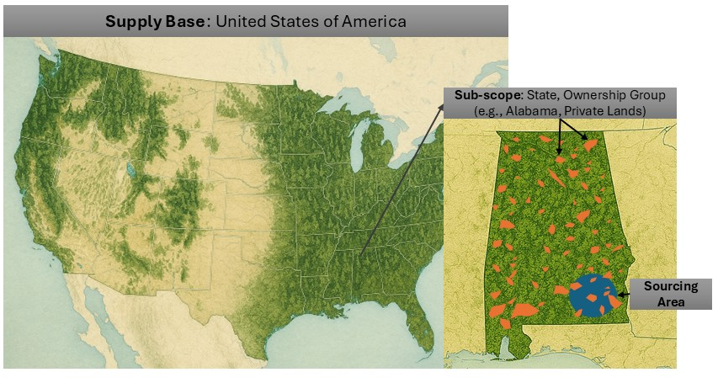

3. Level B Risk Assessment Process

3.1 Summary
This section outlines the process steps required for a US Biomass Producer to conduct a RED III Level B Risk Assessment of their supply base. The guidance provided in this document follows the eight-step process described in Annex D of the SBP EU RED Instruction Document (Bridging Requirements for Meeting the Renewable Energy Directive (EU/2023/2413)) and the REDIIBIO Final Report.
Figure 3. Steps taken to demonstrate compliance with LULUCF criteria at the forest sourcing level.

The fundamental premise of the assessment methodology was to identify homogeneous sub-scopes that could be reasonably aligned with actual sourcing areas, have definable spatial boundaries, and have access to forest carbon stock data at a sufficient scale to enable statistically reliable analysis. The guidance is provided via two distinct and interdependent parts: a) this document, which provides context, background information, and core instructions for Biomass Producers to conduct RED III Level B risk assessments for their sourcing area; and b) a “US REDIII Level B LULUCF” Microsoft Excel file containing data and analysis for carbon stocks to be referenced in assessing Level B risk for biomass sourced within each of the 48 CONUS states.
FIA data on forest carbon stocks were aggregated based on the defined sub-scopes (see Figure 4) for the period spanning from 2000-through the latest available inventory year. Those data were divided into a historical reference period and more recent FIA data (2010-latest available inventory data for most states) that were used to model long-term directional trends in future forest carbon stocks through a simple linear projection. This approach emphasises transparency and reproducibility rather than forward-looking modelling. For most states, the historical reference period aligns with the time period articulated in SBP ID EU RED v2.0 (See box 1) of 2000 – 2009. However, FIA data before this time period were unavailable for six states (CA, NM, OK, OR, WA, and WY) and insufficient to construct a trend (i.e., fewer than 3 data points) for three states (LA, MS, and NV). In these cases, the first three years of inventory data were applied to characterize carbon stocks and trends during the historical reference period. These details are noted for each state within the accompanying “US REDIII Level B LULUCF” Microsoft Excel file.
Box 1: Excerpt from SBP requirements for Biomass Producers: conformance with EU RED Articles 29 (2)–(5) and (6)–(7) –Sustainability criteria for primary feedstock, Section 1.6.3
“Economic operators shall use the reference period of 2000-2009, or another period of similar length and as close as possible to 2000-2009, to facilitate the use of forest inventory data or to mitigate the impacts of natural disturbances or other extreme events. The economic operators shall duly justify the choice of their reference period.”
Because this assessment is intended to inform a Level B risk characterisation rather than to predict future outcomes through complex modelling, it is critical that observed trends in forest carbon stocks be interpreted in the context of their associated uncertainty.
Figure 4. Illustration of Sub-Scope Delineation. Unreserved forest land represent forest lands from which biomass may be legally obtained under federal and state law.

FIA estimates are derived from a sample-based national inventory, and apparent changes in carbon stocks may reflect sampling variability rather than true underlying change. This assessment incorporated FIA-published sampling error estimates by using sample-error-derived 95% confidence intervals to distinguish meaningful directional trends from normal statistical variation in carbon stock estimates. This approach supports a conservative, evidence-based interpretation by avoiding overinterpretation of marginal changes and treating results with overlapping uncertainty as indeterminate. Explicit consideration of uncertainty, therefore, strengthens the credibility, transparency, and robustness of the risk assessment and aligns the analysis with SBP’s risk-based decision framework.
A full description of the methodology applied to produce this guidance to assist BPs in conducting RED III Level II Risk Assessments for sourcing biomass from US forest lands is contained in Annex I of this document.
The section below provides users with detailed step-by-step guidance for completing a RED III Level B Risk Assessment, including integrating the results of the carbon stock assessments specific to their sourcing areas.

3.2 Detailed Instructions for Completing a RED III Level B Risk Assessment
Biomass Producers and other users of this guidance are encouraged to closely follow the instructions provided below for their supply base. Prior to initiating the eight-step process outlined below, it is recommended that users read this entire document, including Annexes, and familiarise themselves with the accompanying data analysis for forest carbon stocks contained in the “US RED III Level B LULUCF” Microsoft Excel file.
For data sources, users may use the following sample text:
Data applied for conducting the risk assessment were sourced from the USDA Forest Service’s Forest Inventory and Analysis (FIA) Program’s Nationwide Forest Inventory, a sample-based forest inventory that provides consistent information on forest extent, composition, growth, removals, mortality, and carbon stocks across all ownerships in the United States. The inventory is based on a permanent network of field plots that are measured on a rotating basis, with standardised methods applied nationwide to ensure comparability across states and regions. Because FIA estimates are derived from a statistical sample rather than a complete census, reported values represent population-level estimates and are accompanied by measures of sampling error to support appropriate interpretation of uncertainty.
The “SOURCE” tab located within the accompanying “US RED III Level B LULUCF” Microsoft Excel file provides direct URLs to the outputs of the FIA EVALIDator web each sub-scope included in this document.

Step 1: Define the spatial boundaries of the compliance check
Identify all relevant sub-scopes. Each sub-scope is defined by a combination of one US state and one ownership classification (e.g., Alabama Private, or South Carolina National Forest). Note that the analysis of forest carbon stocks contained in this guidance includes only unreserved forest land because it excludes areas designated for permanent protection, such as wilderness areas, that are legally restricted from timber harvest. Refer to Annex I for the definition of forest land and further description of unreserved forest land.

Step 2: Define relevant carbon pools
All five forest carbon pools were included in the analysis of carbon stocks for this assessment. List the five carbon pools in forests, as defined by the UNFCCC: live aboveground, live belowground, dead wood, litter, and soil organic. The FIA program defines the carbon pools in accordance with UNFCCC guidance, as detailed in Annex I.

Step 3: Define a historical reference period
The selected historical reference period for the US RED III Level B Risk Assessment for most states will be 2000 – 2009. This time period aligns with the proposed period in the REDBIOIII guidance. However, FIA data for this entire timeframe are not available across all states and sub-scopes at this time, and therefore their historical reference period reflects the first three available inventory years for that state. Producers whose sourcing areas overlap with those states (i.e., CA, LA, MS, NV, NM, OK, OR, WA, WY) should reference the tab that corresponds to their state in the accompanying US RED III Level B LULUCF Microsoft Excel to confirm the historical reference period. Table 5 in Annex I also lists the inventory years that were selected to construct the historical reference period for those states.

Step 4: Quantify carbon stocks and sinks of the sourcing area for the historical reference period
Using the accompanying “US RED III Level B LULUCF” workbook, select the tab for the state that corresponds to the sub-scope defined in Step 1 above. Within the state tab, locate the FIA Inventory Data table in the top left corner listing total forest carbon for each ownership group. Create a table that displays the carbon stocks for the sub-scope of interest (e.g., Alabama, Private Forest Lands) by copying the data for the historical reference period (2000 – 2009). For demonstration purposes, a table for private forest lands in Alabama is provided below. Make sure to list the source for each table and graph. For multiple sourcing areas, this step should be repeated for each defined sub-scope. Note that forest carbon stocks are listed in metric tonnes.
A detailed breakdown of carbon total carbon stocks in each state divided by carbon pool is also available in the bottom left corner of the tab.
Table 2. Sample table listing total forest carbon and forest carbon by pool for private forest lands: historical reference period, Alabama (metric tonnes).
Year | Alabama Private Forest Lands, Total Forest Carbon  (all 5 pools, in metric tonnes, on unreserved forest land)
2000 | 1,285,588,950
2001 | 1,281,614,668
2002 | 1,282,118,839
2003 | 1,283,353,466
2004 | 1,286,784,890
2005 | 1,294,563,625
2006 | 1,300,932,188
2007 | 1,300,839,479
2008 | 1,303,106,109
2009 | 1,311,530,940

To further display total annual carbon stocks, users can also copy and paste the bar chart located in the “US RED III Level B LULUCF” worksheet immediately to the right of the total forest carbon table corresponding to the target sub-scope (e.g., Private lands). For demonstration purposes, the corresponding bar chart for private forest lands in Alabama is provided below.
Figure 1. Sample bar chart for total forest carbon stocks with confidence intervals displayed for the historical reference period on private forest lands, Alabama (metric tonnes).

Step 5: Define the length of the future long-term period
The future long-term period approximates the period of 30 years beyond the last year of inventory data as suggested in the REDIIBIO guidance document. For the sake of consistency, the future long-term period used for this assessment ends in 2054 for each state. Because the last year of available inventory data varies slightly by state, the start of the future long-term period also varies by state. To determine the future long-term period for each sourcing area, using the “US RED III Level B LULUCF” workbook, select the tab for the corresponding state, go to the bottom of the table listing forest carbon totals (top left table on the tab) and list the first and last year below the “Forecasted Data” heading in the table. So, for example, Alabama’s future long-term period is 2025-2054 because the last year with carbon stock data listed is 2024.

Step 6: Describe forest management practices in a sourcing area for the future long-term period
Biomass producers should describe the forest management practices expected to be employed in their specific sourcing areas in the long term. Because it is difficult to foresee how forest management practices may evolve over the next 30 years, current practices may serve as a reasonable proxy for future practices in most circumstances.
To the extent that typical forest management practices may vary between landowner groups and states, they should be described for each defined sub-scope (state + ownership group). Alternatively, if forest management practices are common among sourcing areas in multiple sub-scopes, they can be described collectively for similar areas.
Several resources are available to assist in describing forest management practices within specific sub-scopes, including the following:
- FIA One-Click State Factsheets
- State Timber Product Output (TPO) One-Click Factsheets (available for eastern states only)
- State Forest Action Plans (FAP)
- State BMPs
- State Forest Practices Acts (FPA), if applicable (e.g., CA, ID, ME, MA, MI, MN, NH, NC, OR, PA, SC, VT, VA, WA, WV, WI)
- Forest Management Plans (FMP)
- National Woodland Owner Survey Dashboard (NWOS)
- Local knowledge of procurement staff

Table 3. Potential Sources for Description of Forest Management Practices within Sub-scopes.
Forest Management Variables | FIA Fact Sheet | TPO Fact Sheet | State FAP | BMPs | State FPA | FMP | NWOS | Local Staff
Annual harvest level | X | X |  |  |  | X
Tree species composition | X |  | X |  |  | X |  | X
Forest land area by Ownership type | X |  | X |  |  | X | X
Forest carbon sequestration | X |  | X
Forest reproductive material used (provenance) |  |  | X |  |  | X |  | X
Thinning intensity and frequency |  |  |  |  |  | X | X | X
Management objectives |  |  |  |  |  | X | X
Cutting regime (e.g., clearcutting, shelterwood, group or tree selection, coppice) |  |  | X |  | X | X |  | X
Other management decisions (e.g., fertilisation, drainage, herbicide and pesticide application, etc.) |  |  |  | X | X | X | X | X
Average minimum and maximum rotation length |  |  | X |  |  | X |  | X
Production by product type |  | X

A sample introduction is provided in the box below, followed by high-level regional descriptions that can be adopted and modified to align with a biomass producer's specific sourcing areas. Emphasis should be placed on annual harvest levels, tree species composition, methods of regeneration, silvicultural practices employed (harvest regimes, timber stand improvement activities, herbicide and pesticide application, fertilisation), rotation lengths, intensity and frequency of harvest entry. The descriptions should be supplemented with high-level (e.g. state-level) data when available.
Box 2: Sample introduction for description of forest management practices in the sourcing areas for the future long-term period.
While some silvicultural systems are more common in some regions than others, a wide range of practices is typically employed. Therefore, forest management practices commonly employed within sourcing areas can be described only in general terms. Both even-aged and uneven-aged silvicultural harvest regimes may be employed, depending on species composition, tree age and stocking, desired future conditions, forest health, site productivity, and other factors. Silvicultural interventions may be designed to achieve multiple-use objectives, ecological restoration, forest health and resiliency, recreation, conservation or other goals. Forest regeneration following harvest and natural disturbance events may include tree planting, seeding, prescribed burning, mechanical site preparation, natural regeneration, or a combination of these techniques. Precommercial mechanical thinning, herbicide applications, and fertilisation are employed at varying frequencies as warranted by site-level circumstances and consistent with landowner objectives. Species composition, site productivity, ecosystem dynamics and disturbance regimes can vary considerably between regions and within regions. State BMPs, Forest Practices Acts, and other regulatory and voluntary frameworks may impose limitations on, or prohibit, specific management activities such as clear-cut harvesting or harvesting within riparian zones.
While silvicultural practices have evolved over time, innovations and adaptations typically relate to well-established, fundamental silvicultural and ecological principles. Adaptations to current and anticipated impacts of climate change have been integrated into accepted silvicultural practices for over a decade. As such, there is no evidence to suggest forest management practices will experience significant change in the long-term future, and no basis from which to make such predictions. Therefore, current practices are assumed to provide the best approximation of future practices for projecting long-term trends in forest carbon stocks.
In the Southeast, clearcutting followed by planting seedlings of local provenance from tree-improvement breeding programs is standard practice for loblolly and shortleaf pine stands. Herbicide site preparation and release, along with one or two applications of fertiliser, are often incorporated into intensive silvicultural systems on nutrient-poor sites, for example, on private industrial timberlands. Oak/hickory stands, which account for about 40% of timberlands in the Southeast region, are commonly managed with intermediate thinning and crop-tree release, followed by shelterwood and group selection regeneration harvests, and the use of prescribed fire. Other common regeneration systems include clearcutting with reserves in mixed pine/oak stands (e.g., retained oak in the overstory), and variants of irregular shelterwood harvests. Chemical and mechanical control of invasive species are common practices within the region.
In the Northeast region, uneven-aged systems such as single-tree selection and various forms of group selection are typical in northern hardwood forest types. Even-aged management techniques such as clearcutting, clearcutting with reserves, shelterwood, and seed-tree harvests are common in less productive hardwood stands, as well as in spruce-fir-aspen stands in northern New England (e.g., northern Maine).
In the Midwest Region, even-aged silvicultural regimes are typically employed in aspen, spruce/fir, white/red pine and oak stands. Clearcuts, clearcuts with reserves, shelterwood, and seed-tree harvests are commonly accepted regeneration-harvesting methods. As with the Northeast Region, uneven-aged systems such as single-tree selection and multiple variants of group selection harvests are typical in the more productive northern hardwood forest types.
Forest management practices in the Western Region are highly diverse. In the Pacific Northwest (e.g., western WA, OR, northern CA), silvicultural practices can range from variable retention harvests, selective thinning, and old-growth retention accompanied by prescribed fire in mixed conifer stands, to even-aged techniques such as clearcutting, shelterwood and seed tree harvests in intensively managed Douglas-fir, redwood, and lower productivity sites east of the Cascade mountain range. Thinning for fire resilience and selective harvest in mixed conifer forests, with even-aged regeneration in drier sites are typical in the Intermountain and Rocky Mountain portions of the western region (ID, MT, NV, CO, UT, WY, Central and Southern CA).
The Southwest Region is characterised by its arid climate and relatively low productivity. Silvicultural systems in Arizona and New Mexico commonly emphasise restoration and fire resilience through thinning, uneven-aged selection and prescribed fire in dry mixed-conifer, ponderosa pine, and pinyon-juniper woodlands. Even-aged systems, such as shelterwoods, are employed on higher-productivity Ponderosa pine sites.

Step 7: Quantify mean carbon stocks and sinks over the future long-term period
The carbon stocks estimated for the long-term future were derived by constructing a simple linear trend based on FIA data. The inventory years used to construct the trend for the future long-term period in most states is 2010 through the latest available inventory year at the time this guidance was developed. However, CA, LA, MS, NV, NM, OK, OR, WA, WY deviate from this time period due to a lack of available data for the historical reference period and therefore producers should reference the tab that corresponds to their state in the accompanying “US RED III Level B LULUCF” Microsoft Excel to confirm. These projections are displayed within each of the state tabs in the “US REDIII Level B LULUCF_12172025” Microsoft Excel file, under the “Forecasted Data” row in the “<State>- Forest carbon total: all 5 pools, in metric tonnes, on unreserved forest land” table located in the upper left corner of the worksheet.
Users can also copy and paste the bar chart to the right of the “<State>- Forest carbon total: all 5 pools, in metric tonnes, on unreserved forest land” table corresponding to the sub-scope of interest. This bar chart illustrates the data points used for projecting the future long-term carbon stocks and their confidence intervals and displays the linear trend that reflects the forecasted future long-term carbon stocks. For demonstration purposes, the corresponding bar chart for private forest lands in Alabama is provided below (Figure 5). These data were used to construct the future long-term period forest carbon stock estimates presented as a red trend line (metric tonnes). Make sure to list the source for each table and graph.
Figure 2. Sample bar chart for total forest carbon stocks and confidence intervals on Private Forest Lands in Alabama for the future long-term period, 2010-2024.

The mean carbon stocks for those forecasted data (i.e., the future long-term period) are shown in the “State Summary Preliminary” tab in the US RED III Level B LULUCF Microsoft Excel file. Users should locate the row corresponding to the state and column corresponding to the sub-scope defined in Step 1. Columns L-P list the calculated mean carbon stocks over the future long-term period based on the analyses conducted in the individual state-specific tabs. For multiple sourcing areas, this step should be repeated for each applicable sub-scope. Note that forest carbon stocks are listed in metric tonnes.

Note that in some cases, apparent trends in forest carbon stocks as projected for the future long-term period should be scrutinised. Sudden year-to-year changes in forest carbon stocks derived from FIA data can be a result of methodological or definitional changes rather than actual biophysical losses. The FIA program periodically revises forest definitions, plot classification rules, estimation procedures, and incorporates new measurement panels as inventories are updated, which can result in artificial discontinuities in reported stocks. Thus, short-term drops in FIA-based carbon estimates may reflect inventory design and accounting updates, not true changes in forest carbon, and should be interpreted in light of methodological revisions and associated uncertainty. For example, this may be the case for Louisiana's National Forest System lands sub-scope which shows a sharp drop in carbon stocks between 2013 and 2014 (see Figure 6 below).

Figure 7. Projected long term future forest carbon stocks on National Forests in Louisiana.
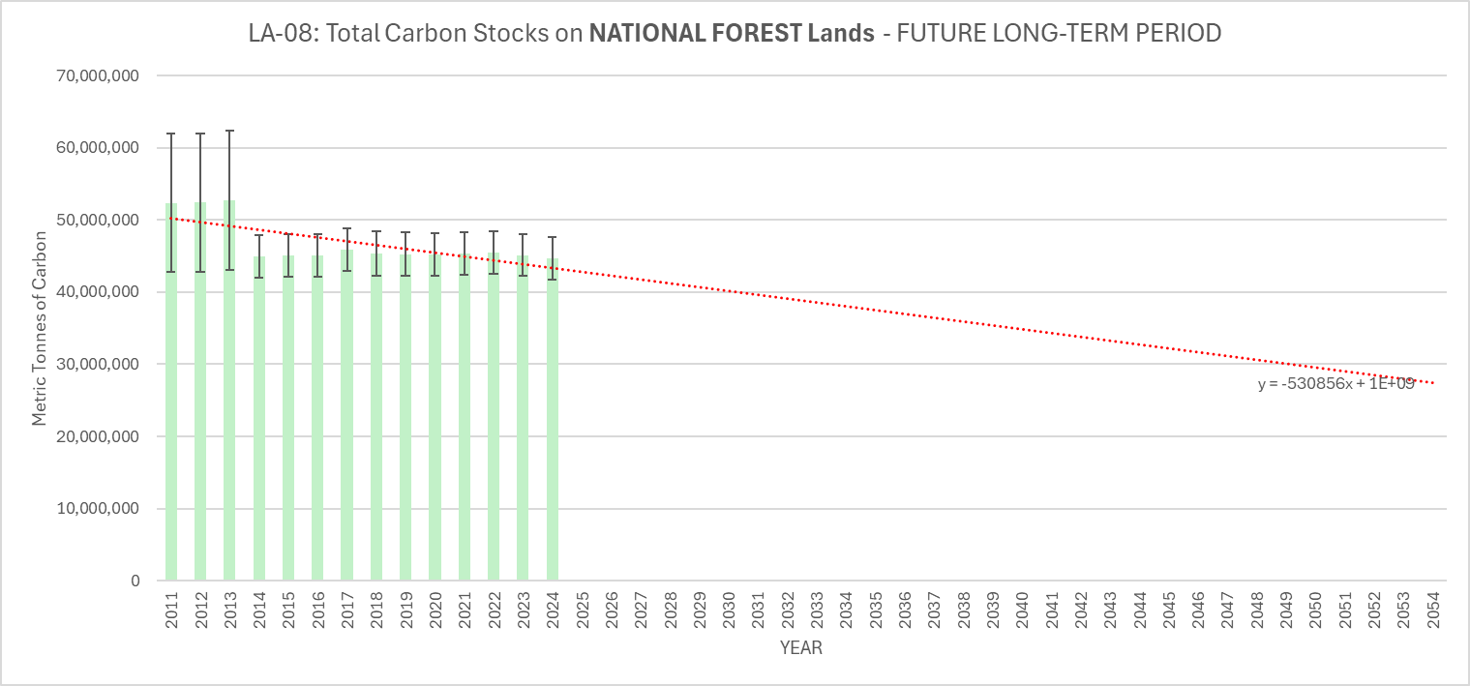

In these cases, producers may wish to consider alternative data sources to demonstrate forest carbon stocks and use those data to construct updated linear trends of projected future forest carbon stocks that may better reflect the carbon stocks in the sourcing area. This may be done through direct consultation with forest land managers within their sourcing area and/or consultation with FIA staff. Alternatively, there may be publicly available data that could be leveraged to better characterize the fluxes in the producer's sourcing area. For example, disaggregated 2005-2022 estimates of greenhouse gas stocks and fluxes are available for each National Forest in the dataset “Greenhouse gas emissions and removals from forest land, woodlands, and urban trees in the United States, 1990-2022: Estimates and quantitative uncertainty for individual states, regional ownerships, National Forests, and Tribal Ownership” (Walters et al. 2024) and can be downloaded from the U.S. Forest Service's Research Data Archive at this link.

Users should also understand that the coarse modelling approach applied to derive the future long-term period carbon stock estimates has several limitations, which are further articulated and justified in Step B.7 of the methodology in Annex I. In short, the linear trend developed to represent carbon stocks over the long-term future period:
- does not attempt to predict fine-scale year-to-year variability,
- can be agnostic to fine-scale site- and stand-level structure,
- intentionally prioritises directional insight over precise forecasting.

As such, additional steps to contextualise the results of the linear trend are captured in Step B.8 below.

Step 8: Compare the future carbon stocks with the historical reference period.
As described in Step B.7, The “State Summary Preliminary” tab in the accompanying US RED III Level B LULUCF Microsoft Excel file displays the mean carbon stocks over the historical reference period (columns G-K) as well as the mean carbon stocks over the future long-term period (columns L-P). Columns B-F display the difference between the two periods. Positive numbers indicate the future long-term carbon stocks may be higher than those estimated for the historical reference period. Negative numbers indicate that future long-term carbon stocks may be less than those estimated for the historical reference period.
However, the projected future long-term carbon stock estimates derived from the linear trend are not, on their own, sufficient to determine whether forest carbon stocks are stable or decreasing for purposes of a Level B risk assessment. These projections are extrapolations of observed data and must be interpreted in the context of the uncertainty associated with the underlying measurements. The FIA program publishes sampling error explicitly to support appropriate interpretation of inventory estimates, recognising that data reliability varies across states, ownership categories, and forest conditions. In some sub-scopes, confidence intervals are relatively narrow and provide a strong basis for trend interpretation, while in others, uncertainty may be substantial due to factors such as limited plot density and staggered remeasurement cycles, high sampling variance in small or heterogeneous ownership classes, disturbance-driven variability associated with wildfire, storms, insects, disease, or harvest pulses, and nonlinear ecological dynamics including regrowth and age-class transitions that are not well captured by short-term linear trends.
Therefore, an additional check was applied to present results within the context of the sampling error and evaluate whether the projected long-term average carbon stock falls within the 95 percent confidence interval of the data used to construct the trend (i.e., 2010 through the most recent available FIA inventory year). This comparison helps determine whether the projected value is statistically distinguishable from historical observations, given FIA sampling error.
Where the projected future long-term average carbon stock falls within the historical confidence interval, the projection is considered consistent with observed conditions, and carbon stocks may be interpreted as stable within the bounds of uncertainty. When the projected value falls outside the confidence interval or when uncertainty is large relative to the estimated stocks, results are interpreted conservatively, reflecting the limits of the available data rather than definitive evidence of change.
The “State Summary Final” tab in the accompanying US RED III Level B LULUCF Microsoft Excel file reflects the final Level B risk assessment results for each defined sub-scope, considering the difference between the mean carbon stocks over the historical reference period and the future long-term period as well as whether or not the projected values fall within the 95 percent confidence intervals associated with the data used to construct the forecast. These results are also included in Table 5 (see Section 4 Results). Users should locate the row corresponding to the state and column corresponding to the ownership group defined in Step 1.
Users can consider including the sample text presented in Table 4 in their compliance documentation, based on the series of potential combinations of factors considered to render the results ultimately presented in the “State Summary Final” tab in the accompanying US RED III Level B LULUCF Microsoft Excel file. These analysis results reflect a combination of sub-scope results from the State tabs, the State Summary Preliminary tab, the State Summary Final tab, and the Statistical Analysis tab in the US RED III Level B LULUCF Microsoft Excel file.
Table 4. Sample text for reporting results of comparison between projected future stocks and historical reference period under a range of potential sub-scope conditions.
Sub-scope result | Analysis results | Sample Text
Stable/Increasing | Average forest carbon stocks for the long-term future are expected to be higher than those for the historical reference period. This is evident from the results presented in the “State Summary Preliminary” Tab. | The carbon stocks for sourcing area X were found to be stable/increasing based on a Level B risk assessment conducted in accordance with the REDIIBIO guidelines. The projected average forest carbon stocks for the long-term future are higher than the average carbon stocks observed during the historical reference period, providing no evidence of declining carbon stocks within the scope of the assessment.
Stable/Increasing | Average forest carbon stocks estimated for the future long-term period are estimated to be lower than average carbon stocks over the historical reference period (based on results presented in the “State Summary Preliminary” Tab), but the sourcing area is still labelled as “Stable/Increasing”. This is because the average projected carbon stocks over the future long-term period falls within the average CI for the time period used to construct the trend (i.e, 2010 to present period for most states). In these cases, the result for the corresponding sub-scope in the “Statistical Analysis” tab, columns V-Z says “Yes”. | The carbon stocks for sourcing area X were found to be stable/increasing based on a Level B risk assessment conducted in accordance with the REDIIBIO guidelines. Although the projected average forest carbon stocks for the future long-term period are lower than the average carbon stocks observed during the historical reference period, the projected values fall within the 95 percent confidence intervals associated with the data used to construct the forecast. As a result, the observed difference is not statistically distinguishable from historical conditions given sampling uncertainty, and forest carbon stocks are therefore considered stable within the bounds of uncertainty for purposes of the Level B risk assessment.
Decreasing | Average forest carbon stocks estimated for the future long-term period are estimated to be lower than average carbon stocks over the historical reference period (based on results presented in the “State Summary Preliminary” tab) AND the average projected carbon stocks over the future long-term period falls outside the average CI for the data used to construct the trend for the future long-term period (i.e., 2010-present for most states). In these cases, the result for the sub-scope in the “Statistical Analysis” tab, columns V-Z says “No”. | The carbon stocks for sourcing area X were found to be decreasing based on a Level B risk assessment conducted in accordance with the REDIIBIO Final Report guidelines. The projected average forest carbon stocks for the future long-term period are lower than the average carbon stocks observed during the historical reference period, and the average projected values fall outside of the average 95 percent confidence intervals associated with the data used to construct the forecast. As a result, the projected decline is interpreted as exceeding historical variability as characterized by sampling uncertainty, with projected long-term carbon stocks falling outside the historical average confidence intervals. The sourcing area is therefore characterized as exhibiting a decline in forest carbon stocks within the scope of the Level B risk assessment

4. Results
Table 5 summarises the results of the risk assessment for each sub-scope, based on the risk designations articulated under step B.8 above. These results are also reported in the “State Summary_Final Results” tab of the US RED III Level B LULUCF Microsoft Excel file accompanying this document.
Three distinct results for the risk assessment are displayed in this tab, which are summarized below.
Stable/Increasing. Sub-scopes labelled in this assessment as “Stable/Increasing” met one of the following criteria based on the analysis performed for this risk assessment:
- Carbon stocks for the future long-term period are estimated to be higher than the average carbon stocks for the historical reference period
- Carbon stocks for the future long-term period are estimated to be lower than the average carbon stocks for the historical reference period, BUT the average projected carbon stock for the future long-term period did not exceed the average calculated CI for the 2010-latest available inventory data time period.
Feedstock may be sourced from a sourcing area where the assessment indicates that forest carbon stocks are stable or increasing.
Decreasing. Sub-scopes labelled in this assessment as “Decreasing” met the following criteria based on the analysis performed for this risk assessment:
- Carbon stocks for the future long-term period are estimated to be lower than the average carbon stocks for the historical reference period, and the average projected carbon stock for the future long-term period exceeds the average calculated CI for the 2010-present period.
Feedstock may only be sourced from a sourcing area where Risk Management Measures can demonstrate that carbon stocks are stable or increasing.
N/A. Sub-scopes labelled as “N/A” indicate that the defined ownership group does not exist within the state. In most cases, that is because the state lacks a National Forest.

Table 5. Forest carbon stock assessment conclusions for Sub-scopes
State |  | Total forest carbon stock | Forest carbon stock / Ownership Group
 |  | Total forest carbon stock | National Forest (public) | Other federal (public) | State and local (public) | Private
Alabama | Stable/Increasing |  | Stable/Increasing | Stable/Increasing | Stable/Increasing | Stable/Increasing
Arizona | Stable/Increasing |  | Decreasing | Stable/Increasing | Stable/Increasing | Stable/Increasing
Arkansas | Stable/Increasing |  | Stable/Increasing | Stable/Increasing | Stable/Increasing | Stable/Increasing
California | Stable/Increasing |  | Decreasing | Decreasing | Stable/Increasing | Stable/Increasing
Colorado | Decreasing |  | Decreasing | Decreasing | Stable/Increasing | Stable/Increasing
Connecticut | Stable/Increasing |  | N/A | Stable/Increasing | Stable/Increasing | Stable/Increasing
Delaware | Stable/Increasing |  | N/A | Stable/Increasing | Stable/Increasing | Stable/Increasing
Florida | Stable/Increasing |  | Stable/Increasing | Stable/Increasing | Stable/Increasing | Stable/Increasing
Georgia | Stable/Increasing |  | Stable/Increasing | Stable/Increasing | Stable/Increasing | Stable/Increasing
Idaho | Stable/Increasing |  | Stable/Increasing | Stable/Increasing | Stable/Increasing | Stable/Increasing
Illinois | Stable/Increasing |  | Stable/Increasing | Stable/Increasing | Stable/Increasing | Stable/Increasing
Indiana | Stable/Increasing |  | Stable/Increasing | Stable/Increasing | Stable/Increasing | Stable/Increasing
Iowa | Stable/Increasing |  | N/A | Stable/Increasing | Stable/Increasing | Stable/Increasing
Kansas | Stable/Increasing |  | N/A | Stable/Increasing | Stable/Increasing | Stable/Increasing
Kentucky | Stable/Increasing |  | Stable/Increasing | Stable/Increasing | Stable/Increasing | Stable/Increasing
Louisiana | Stable/Increasing |  | Decreasing | Stable/Increasing | Stable/Increasing | Stable/Increasing
Maine | Stable/Increasing |  | Stable/Increasing | Stable/Increasing | Stable/Increasing | Stable/Increasing
Maryland | Stable/Increasing |  | N/A | Stable/Increasing | Stable/Increasing | Stable/Increasing
Massachusetts | Stable/Increasing |  | N/A | Stable/Increasing | Stable/Increasing | Stable/Increasing
Michigan | Stable/Increasing |  | Stable/Increasing | Stable/Increasing | Stable/Increasing | Stable/Increasing
Minnesota | Stable/Increasing |  | Stable/Increasing | Decreasing | Stable/Increasing | Stable/Increasing
Mississippi | Stable/Increasing |  | Stable/Increasing | Stable/Increasing | Stable/Increasing | Stable/Increasing
Missouri | Stable/Increasing |  | Stable/Increasing | Stable/Increasing | Stable/Increasing | Stable/Increasing
Montana | Stable/Increasing |  | Stable/Increasing | Stable/Increasing | Stable/Increasing | Stable/Increasing
Nebraska | Stable/Increasing |  | Stable/Increasing | Stable/Increasing | Stable/Increasing | Stable/Increasing
Nevada | Stable/Increasing |  | Stable/Increasing | Stable/Increasing | Stable/Increasing | Stable/Increasing
New Hampshire | Stable/Increasing |  | Stable/Increasing | Stable/Increasing | Stable/Increasing | Stable/Increasing
New Jersey | Stable/Increasing |  | N/A | Stable/Increasing | Stable/Increasing | Decreasing
New Mexico | Stable/Increasing |  | Stable/Increasing | Stable/Increasing | Stable/Increasing | Decreasing
New York | Stable/Increasing |  | Stable/Increasing | Stable/Increasing | Stable/Increasing | Stable/Increasing
North Carolina | Stable/Increasing |  | Stable/Increasing | Stable/Increasing | Stable/Increasing | Stable/Increasing
North Dakota | Stable/Increasing |  | Stable/Increasing | Stable/Increasing | Stable/Increasing | Stable/Increasing
Ohio | Stable/Increasing |  | Stable/Increasing | Stable/Increasing | Stable/Increasing | Stable/Increasing
Oklahoma | Decreasing |  | Stable/Increasing | Stable/Increasing | Stable/Increasing | Decreasing
Oregon | Stable/Increasing |  | Stable/Increasing | Stable/Increasing | Stable/Increasing | Decreasing
Pennsylvania | Stable/Increasing |  | Stable/Increasing | Stable/Increasing | Stable/Increasing | Stable/Increasing
Rhode Island | Stable/Increasing |  | N/A | N/A | Stable/Increasing | Stable/Increasing
South Carolina | Stable/Increasing |  | Stable/Increasing | Stable/Increasing | Stable/Increasing | Stable/Increasing
South Dakota | Stable/Increasing |  | Decreasing | Stable/Increasing | Stable/Increasing | Stable/Increasing
Tennessee | Stable/Increasing |  | Stable/Increasing | Stable/Increasing | Stable/Increasing | Stable/Increasing
Texas | Stable/Increasing |  | Stable/Increasing | Stable/Increasing | Stable/Increasing | Stable/Increasing
Utah | Stable/Increasing |  | Stable/Increasing | Stable/Increasing | Decreasing | Stable/Increasing
Vermont | Stable/Increasing |  | Stable/Increasing | Stable/Increasing | Stable/Increasing | Stable/Increasing
Virginia | Stable/Increasing |  | Stable/Increasing | Stable/Increasing | Stable/Increasing | Stable/Increasing
Washington | Stable/Increasing |  | Stable/Increasing | Stable/Increasing | Stable/Increasing | Stable/Increasing
West Virginia | Stable/Increasing |  | Stable/Increasing | Stable/Increasing | Stable/Increasing | Stable/Increasing
Wisconsin | Stable/Increasing |  | Stable/Increasing | Stable/Increasing | Stable/Increasing | Stable/Increasing
Wyoming | Stable/Increasing |  | Decreasing | Stable/Increasing | Stable/Increasing | Stable/Increasing

5. Risk Management Plan
Consistent with RED Article 29(7)(b), REDIIBIO Final Report Section 2.3.3.2, and SBP Standard 1 Guidance for Indicator 3.2.1, if feedstock is sourced from forest areas that cannot be shown to have stable or increasing forest carbon stocks over the future long-term, the biomass producer must demonstrate that management systems are in place at the level of the forest sourcing area that ensure forest carbon stocks, as well as the forests’ ability to function as a carbon sink over the long term, are maintained or enhanced. SBP Standard 1, Indicator 3.2.1 provides a narrowly defined exception, described below as Mitigation Measure Option F.
Biomass producers typically do not own or manage forest lands and are generally considered secondary producers, given that biomass feedstock is a low-value byproduct of timber harvesting operations. Consequently, it is recognised that biomass producers may have limited influence but ultimately cannot entirely control how forests are managed and harvested within their supply areas. However, biomass producers do control where they source feedstock and must exercise caution and due diligence to ensure feedstock is not sourced from forest areas that do not comply with SBP standard requirements and international LULUCF regulations regarding non-declining forest carbon stocks.
Applicability of mitigation measures is associated with specific landowner groups when appropriate, e.g., small non-industrial forest owners, medium & large private owners, etc. These associations take into consideration the scale and intensity of forest operations typically associated with corresponding landowner groups in the US.
Large public agencies (e.g., US Forest Service, state forestry agency) may have unit level (e.g., National Forest level) assessments of forest carbon stock trends, potential impact of harvest on forest carbon stocks, etc. that reasonably approximate the eight-step process employed in this assessment, as described in the REDIIBIO Final Report and SBP Instruction Document EU RED, Annex D. Additionally, some large private industrial forest owners may have long term forest inventory data and/or analyses of forest carbon trends sufficient to conduct a statistically reliable RED III Level B assessment of LULUCF requirements, though perhaps not for all five forest carbon pools.
The following risk mitigation measures are provided as suggested options for US Biomass Producers to meet the above requirements for feedstock sourced from state/landowner sub-scopes designated with declining forest carbon stocks or inadequate data availability in Section 4, Table 5 above. Biomass Producers may also develop their own mitigation measures. Mitigation measures may be implemented individually (e.g., Option A alone) or in combination with other mitigation measures (e.g., Option C plus all or part of Option D, etc.), or in combination with additional mitigation measures developed independently by the Biomass Producer.
The biomass producer must clearly and comprehensively describe and document all risk mitigation measures employed for sourcing feedstock from forest areas determined to have decreasing forest carbon stocks (as reported in Table 5. Regional Risk Assessment Conclusions for Sub-scopes).

5.1 Recommended Risk Management Measures
Option A: Applicable to all forest ownership classes where forest carbon stock is decreasing
Risk Management Measures | Mitigation measure – avoid sourcing  - Do not procure feedstock from sourcing areas designated with specified risk (decreasing forest carbon stock ).  Means of verification  - Develop and communicate a procurement policy supported by senior management that clearly states the requirement that the landowner/forester/logger/supplier at the source forest will not supply feedstock from forests where the forest management activities generating feedstock result in declining forest carbon stocks and/or diminished capacity of the forest to function as a carbon sink in the long term.  - Maintain detailed sourcing records such as sourcing agreements that include at a minimum the date, landowner name and address, legal description for the location of the forest area of origin, species and quantity of feedstock supplied.  Monitoring  - Annual internal and external audits.

Option B: Applicable for sourcing from medium and large public and private forests where forest carbon stock is decreasing.
Risk Management Measures | Mitigation measure – conduct Level B risk assessment  - Collect or acquire statistically reliable pre-harvest forest inventory data for the defined sourcing area to establish a historical baseline for forest carbon stocks, and to allow for projecting future forest carbon stocks beyond the baseline period. Past inventory data should be acquired for as many years as possible (e.g., 2000 – 2009), and for as many forest carbon pools as possible. The area selected must be sufficiently homogeneous to evaluate the risk of declining carbon stocks.  - Project carbon stocks over the future long-term period (30 years) based on collected/provided inventory data, landowner objectives, planned forest management strategies and activities for the sourcing area using process-based or growth-and-yield models (e.g., US Forest Service’s Forest Vegetation Simulator).  - Confirm that the implementation of planned forest management activities produces modelled results that demonstrate forest carbon stocks, as well as the forests’ ability to function as a carbon sink over the long term, are maintained or enhanced.  - If modelled results indicate declining carbon stocks or diminished capacity to act as a carbon sink, do not source feedstock from the area.  Means of verification  - Maintain a copy of the modelling results on file.  - Conduct and document site visits before initiation of harvesting activities and after harvesting is completed to confirm the timber harvest is consistent with the silvicultural prescription and the harvest plan used in the modelling.  - Conduct and document site visits (or provide equivalent evidence) after completion of any associated regeneration activities (inclusive of site prep, release, etc.) to ensure proper implementation.  - Maintain all associated records for at least five years.  Monitoring  - Annual internal and/or external audits.

Option C: Applicable for sourcing from small (< 1,000 ha.), non-industrial forests operating under a written management plan where forest carbon stock is decreasing.
Risk Management Measures | Mitigation measure - verify implementation of management plan and practices consistent with maintaining or enhancing carbon stocks in the long-term  - Ensure silvicultural treatments, timber harvest regimes and associated forest management activities (e.g., regeneration, thinning, release) that generate feedstock are documented in a written management plan and consistent with accepted practices for maintaining or increasing forest carbon stocks and the forests capacity to function as a carbon sink in the long term.  Means of verification  - Maintain a current copy of the written management and/or silvicultural prescription or equivalent on file.  - Site visits are conducted and documented before initiation of harvesting activities and after harvesting is completed to confirm that the timber harvest is consistent with the silvicultural prescription, management plan, and harvest plan.  - Site visits conducted and documented (or equivalent evidence provided) after completion of associated regeneration activities (inclusive of site prep, release, etc.) to ensure proper implementation.  - Maintain all associated records for at least five years.  Monitoring  - Annual internal and/or external audits.

Option D: Applicable for sourcing from small (< 1,000 ha.), non-industrial forests operating without a written management plan where forest carbon stock is decreasing.
Risk Management Measures | Mitigation measure - training, education, and assurance of practices consistent with maintaining or enhancing carbon stocks in the long term  - Develop and communicate a procurement policy supported by senior management that clearly states the requirement that the landowner/forester/logger at the source forest will not supply feedstock from forests where the forest management activities generating feedstock result in declining forest carbon stocks and/or diminished capacity of the forest to function as a carbon sink in the long term.  - Provide training and educational materials to landowners and loggers regarding silvicultural treatments, timber harvest regimes and associated forest management activities (e.g., regeneration, thinning, release) applicable to the sourcing area that are consistent with accepted practices for maintaining or increasing forest carbon stocks and the forest's capacity to function as a carbon sink in the long term.  - For indirect sourcing through suppliers, require that all suppliers providing feedstock from within the sourcing area enter into binding agreements to ensure appropriate training and educational materials are delivered to associated loggers.  - Secure written assurance (e.g., within a sourcing agreement) from landowner or formally designated landowner representative of ongoing commitment to implementation of forest management and timber harvesting practices consistent with maintaining or increasing forest carbon stocks and the forest's capacity to function as a carbon sink in the long term.  Means of verification  - Maintain a copy of training records and signed sourcing agreements on file.  - Site visits are conducted and documented before initiation of harvesting activities and after harvesting is completed to confirm that the timber harvest is consistent with the silvicultural prescription, management plan, and/or harvest plan.  - Site visits conducted and documented (or equivalent evidence provided) after completion of associated regeneration activities (inclusive of site prep, release, etc.) to ensure proper implementation.  - Maintain all associated records for at least five years.  Monitoring  - Annual internal and/or external audits.

Annex I – Methodology
The methodology used to analyse forest carbon stocks and to develop this RED III Level B Risk Assessment guidance document follows the guidance and steps reflected in Figure 2 and is detailed in the section below. The outcomes from this interpretation of the guidance, as demonstrated in Figure 2, are not termed “Compliant” or “Not Compliant” (as depicted in Figure 5) in this guidance. Rather, they are grouped into two explicit categories: Stable/Increasing (meaning Compliant or Low Risk) and Decreasing (meaning Not Compliant or Specified Risk). Results also present sub-scopes labelled as N/A for sub-scopes that do not exist (e.g., National Forests in Rhode Island). Feedstock sourced from areas sub-scopes labelled as “Decreasing” can potentially demonstrate compliance by implementing “Risk Management” measures outlined in Section 5.1 of the main body of this document. The results from the analysis of FIA forest carbon stock data are presented in the US RED III Level B LULUCF ” Microsoft Excel file accompanying this document.
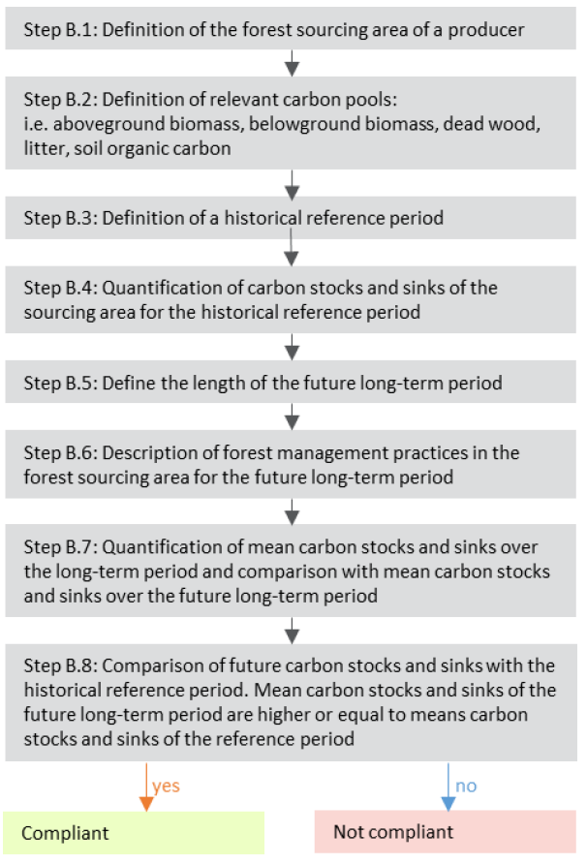
Figure 8. Steps to demonstrate LULUCF criteria compliance at the forest sourcing level for producers seeking to demonstrate “Level B” compliance (Article 29.7(b)), sourced from the REDIIBIO report. For this Risk Assessment, outcomes are not termed “Compliant” or “Not Compliant” and are instead grouped into explicit two alternative categories, as follows: "Stable/Increasing” (Compliant) or "Decreasing” (Not Compliant)..
The so-called “International” or “Resources Planning Act” definition of forest, as defined by the FIA program (see box 1), was selected for this analysis (see Murray et al. 2025 for more information on US forest land definitions).

Step B.1: Define the spatial boundaries of the compliance check
To ensure compliance with the delineation of sub-scopes as defined in the REDIIBIO report and the SBP ID EU RED v2.0, the US LULUCF Level B risk assessment delineated them based on data that could be consistently and transparently sourced from the FIA’s EVALIDator web app and would credibly reflect the biophysical and socioeconomic factors that influence forest conditions. These delineations are presented below:

- Conterminous US states: Given the size and heterogeneity of the US land base, state boundaries provide the most appropriate initial stratification for delineating sub-scopes. In the United States, federal laws apply nationwide, but the federalised system means each state maintains its own forest policies, best management practices, and incentive programs that shape local management regimes. Furthermore, delineating by state aligns with the operational structure of the FIA program. Following the FIA’s transition from periodic to annualised inventories in the early 2000s, states adopted the new system at varying levels of intensity, influenced by their respective resources, management priorities, and the economic role of private forestlands. Some states allocated additional funding to increase sampling intensity, whereas others—particularly in the western United States—did not expand inventories to the same extent. Consequently, the availability, frequency, and resolution of annual FIA data differ by state, further supporting the use of state boundaries as a consistent and practical foundation for stratification.

- Unreserved forest land: The FIA database enables stratification based on specific subsets of the forest definition that reflect legal (e.g., timberland) or biophysical characteristics (e.g., woodlands). For this assessment, unreserved forest land was selected as the appropriate subset because it excludes areas designated for permanent protection, such as wilderness areas, legally restricted from timber harvest. Isolating the analysis to unreserved forest land helps ensure that the sourcing area reflects only those forestlands from which biomass may be legally obtained under federal and state law. This stratification therefore aligns the assessment with both regulatory requirements and the practical realities of permissible biomass supply.
Box 2: Forest land. A land-use category that includes areas at least 120 feet (36.6 m) wide and at least one 1 acre (0.4 ha) in size with at least ten percent cover (or equivalent stocking) by live trees, including land that formerly had such tree cover and that will be naturally or artificially regenerated. Trees are woody plants having a more or less erect perennial stem(s) capable of achieving at least 3 inches (7.6 cm) in diameter at breast height, or 5 inches (12.7 cm) in diameter at root collar, and a height of 16.4 feet (5 m) at maturity in situ. Forest land includes all areas recently having such conditions and currently regenerating or capable of attaining such conditions in the near future. Forest land also includes transition zones, such as areas between forest and non-forest lands, which have at least ten percent cover (or equivalent stocking) with live trees and forest areas adjacent to urban and built-up lands. Unimproved roads and trails, streams, and clearings in forest areas are classified as forest if they are <120 feet (36.6 m) wide or an acre (0.4 ha) in size. However, land is not classified as forest land if it is completely surrounded by urban or developed land, even if it meets the tree area and cover requirements for forest land. These areas are classified as settlements. In addition, forest land does not include land that is predominantly under an agricultural land use.

- Ownership group: The FIA database enables stratification by forest ownership groups, providing another opportunity to capture the carbon dynamics among more homogenous forest land holdings. Because public and private forest lands differ markedly in management objectives, regulatory frameworks, and disturbance regimes, which all influence carbon dynamics, subdividing private and public forests captures additional variation in management intensity and land-use constraints. In addition, carbon stocks in public forests were further subdivided by the National Forest System, state and local, and other federal ownerships. This stratification ensures that carbon estimates reflect the real conditions under which different ownership groups manage forests and helps identify where carbon gains, risks, or mitigation opportunities are most likely to occur.

Step B.2: Define relevant carbon pools
The five carbon pools in forests, as defined by the UNFCCC, were included in the analysis of carbon stocks for this assessment. The “US RED III Level B LULUCF” Microsoft Excel file accompanying this guidance offers individual tabs reflecting the analysis for each state where the results reflect both the forest carbon total (all 5 pools, in metric tonnes, on unreserved forest land), delineated by ownership group, for each year of available inventory data, as well as a breakdown of carbon stocks by pool for each year of available inventory data. The FIA program defines the carbon pools in accordance with UNFCCC guidance, as replicated below:
Pool 1: live aboveground (oven-dry metric tonnes): Carbon in understory aboveground. Carbon (tons per acre) in the aboveground portions of seedlings and shrubs. Estimated from models based on geographic area, forest type, and (except for non-stocked and pinyon-juniper stands) live tree carbon density.
Carbon in the aboveground portion of the tree. The carbon (pounds) in the aboveground portion, excluding foliage, of live trees with a diameter >=1 inch, and dead trees with a diameter >=5 inches. Calculated for both timber and woodland species.
Pool 2: live belowground (oven-dry metric tonnes): Derived from 2 components (one condition-level component and one tree-level component): Carbon in understory aboveground (see above)
Pool 3: dead wood (oven-dry metric tonnes):
- Carbon in the dead. Carbon (tons per acre) of woody material >3 inches in diameter on the ground, and stumps and their roots >3 inches in diameter. Estimated from models based on geographic area, forest type, and live tree carbon density. This modelled attribute is a component of the EPA's Greenhouse Gas Inventory and is not a direct sum of Phase 2 or Phase 3 measurements.
- Carbon in standing dead. Carbon (tons per acre) in standing dead trees, including coarse roots, is estimated from models based on geographic area, forest type, and (except for non-stocked stands) growing stock volume.
Pool 4: litter IPCC (oven-dry metric tonnes): Carbon in litter. Carbon (tons per acre) of organic material on the floor of the forest, including fine woody debris, humus, and fine roots in the organic forest floor layer above mineral soil. Estimated from models based on geographic area, forest type, and (except for non-stocked and pinyon-juniper stands) stand age.
Pool 5: soil organic (oven-dry metric tonnes): Carbon in organic soil. Carbon (tons per acre) in fine organic material below the soil surface to a depth of 1 meter. Does not include roots. Estimated from models based on geographic area and forest type (Smith and Heath 2008). This modelled attribute is a component of the EPA's Greenhouse Gas Inventory and is not a direct sum of Phase 2 or Phase 3 measurements.
More information on FIA’s nationwide inventory data collection process and modelling procedures can be found at the following links:
FIA National Scale Volume Biomass Estimators
Bechtold & Patterson (2005): The Enhanced FIA Program—National Sampling Design and Estimation Procedures

Step B.3: Determine a historical reference period
For most sub-scopes, the selected historical reference period of 2000-2009for the US risk assessment aligns with the proposed period in the REDIIBIO guidance. However, full, state-wide data for this entire timeframe are not available across all states and sub scopes at this time. The FIA program moved from periodic inventories to a rolling annual system beginning in the early 2000s, and that transition happened unevenly across states. Most states have at least three data points for the 2000-2009 period, though some are more limited (see Table 5). In cases where fewer than three data points are available from 2000 - 2009, the first three years for which full, state-wide inventory data were available were used to construct the historical reference period. Two states, (Oklahoma, Texas) reported inventory data for only a portion of the state for some years during 2000 – 2009 historical reference period and only the years for which a full statewide inventory were available were used to evaluate the historical reference period.
Table 6. US States for which there were limited or no annual inventory data for the historical reference period and the years that were selected to construct the historical reference period for each
 | No Data | Limited to one datapoint | Limited to two datapoints
States | - California (2010,2016,2017)  - New Mexico (2013,2014,2015)  - Oklahoma (2010,2011,2012)  - Oregon (2010,2017,2018)  - Washington (2011,2017,2018)  - Wyoming (2012,2013,2014) | - Nevada (2005,2012,2013) | - Louisiana (2008,2009,2010)  - Mississippi (2006,2009,2010)

Step B.4: Quantify carbon stocks and sinks of the sourcing area for the historical reference period
Forest carbon stocks were estimated for each of the sub-scopes for the historical reference period using available data sourced from the FIA’s EVALIDator web app and analysed following the steps outlined below, and calculation methods can be tracked transparently in the “US RED III Level B LULUCF” Microsoft Excel file accompanying this guidance. Because data for the 2010-latest available inventory date were used to construct the linear regressions for the future long-term period, the section below describes how data were sourced and analysed for all available inventory years 2000-present.
- Source carbon stock estimates from the EVALIDator web app: For each state, the EVALIDator web app was used to generate estimates of forest carbon stocks, delineated based on the sub-scope criteria defined above (i.e., international forest definition, unreserved forest land, ownership group). Outputs for each state for all available inventory years 2000-present (total forest carbon stocks & associated sampling error percent and forest carbon stocks by pool) were pasted into corresponding state tabs in the Excel file.

- Calculate the Confidence Interval (CI’s) for each sourcing area: In addition to quantifying carbon stocks for each sub-scope, confidence intervals were also calculated for total carbon stocks (i.e., not at the individual pool level) to quantify the uncertainty inherent in FIA’s sample-based carbon stock estimates and to ensure that year-to-year differences are interpreted appropriately. Because FIA values are derived from statistically representative samples rather than a complete wall-to-wall inventory, observed changes between consecutive inventory years may reflect sampling variability rather than real shifts in forest carbon. Confidence intervals provide a transparent, quantitative measure of this uncertainty, allowing users to distinguish meaningful changes from those that fall within normal sampling error. Evaluating annual differences in light of these intervals prevents over-interpretation of noise in the data and supports more reliable conclusions about actual carbon stock dynamics.

To construct confidence intervals around FIA-derived carbon stock estimates, sampling error percentages reported by the FIA EVALIDator tool, expressed at the 68% confidence level (approximately one standard error), were converted to 95% confidence intervals by multiplying the sampling error percentage by a factor of 2.0. This approach closely approximates the standard normal z-value of 1.96 but yields a slightly more conservative interval, which is appropriate for assessments intended to avoid overstating year-to-year or period-to-period changes. The resulting confidence interval half-widths were calculated by applying the adjusted sampling error percentage to each ownership-specific and total-state estimate.

Step B.5: Define the length of the future long-term period
The future long-term period is defined as the number of years between the year after the last available inventory year for each state and 2054, covering approximately the suggested period of 30 years in the REDIIBIO guidance, depending on the state. So, for example, Alabama’s future long-term period is 2025-2054 (29 years), whereas Idaho’s is 2024-2054 (30 years).

Step B.6: Describe forest management practices in a sourcing area for the future long-term period
Forest management practices employed in the contiguous US include a wide array of silvicultural interventions, ecological restoration activities, and resiliency treatments. Forest management practices common within geographic ecoregions can be described only in very general terms. While some silvicultural systems are more common than others regionally, typically a wide range of practices are employed.

Biomass producers are encouraged to describe the forest management practices commonly employed within their specific supply areas. Specific components of forest management practices listed in the SBP guidance and the REDIIBIO Final Report are mentioned specifically in the guidance as points of emphasis. Potential resources are provided to assist Biomass Producers in developing suitable descriptions of forest management practices, and to supplement those descriptions with complementary data when available.

Step B.7: Quantify mean carbon stocks and sinks over the future long-term period
The carbon stocks over the future long-term period were modelled by calculating a simple linear trend based on available inventory data post-2010 for each sub-scope. This decision was made due to the complexity, data requirements, and methodological variability associated with process-based or growth-and-yield models (e.g., the Forest Service’s Forest Vegetation Simulator), which require detailed stand-level inputs, species-specific parameters, management prescriptions, and disturbance probabilities that are not consistently available across states or ownership categories. Applying such models at large spatial scales also introduces assumptions and model-dependent uncertainties that may exceed those associated with a transparent empirical extrapolation.

At the same time, a simple linear trend carries its own limitations, because FIA observations reflect historical conditions that may not persist into the future. Linear extrapolation cannot capture nonlinear changes in age structure, management, or disturbance regimes (see Box 3). For this reason, the projections are intended to represent broad directional indicators rather than predictive forecasts, providing a practical, reproducible, and consistently applicable approach when more sophisticated modelling frameworks are infeasible for the scope and scale of this assessment.
Box 3: Key concepts for understanding the constraints of using FIA data for predicting future carbon stocks:
- Sampling design limitations: Sparse plots in some states/ownerships and staggered remeasurement cycles introduce substantial year-to-year variability.
- Large sampling variance: Small ownership categories and heterogeneous forest conditions can cause FIA estimates to fluctuate independently of true underlying trends.
- Disturbance-driven noise: Wildfire, storms, insects, disease, and harvest pulses create abrupt biomass changes that may not align with FIA sampling timing.
- Nonlinear ecological dynamics: Regrowth, age-class transitions, and post-disturbance recovery unfold over decades, making short-term linear trends a coarse approximation.
- Short observation window: The 10–14 year dataset used to create the future linear trend captures only a fragment of long-term forest carbon cycles, limiting the precision of 30-year projections.

Step B.8: Compare the future carbon stocks with the historical reference period.
As described above, the linear trend devised for each sub-scope to characterize the carbon stocks over the future long-term period is a coarse approach. It is important to recognize that the linear trend does not account for the uncertainty inherent in FIA inventory design (see Box 3) which is fundamentally important for accurately interpreting the reported carbon stocks in each sub-scope. Nevertheless, applying a highly technical or statistically complex evaluation framework risks creating a false sense of precision inconsistent with the projection approach.

Therefore, to evaluate whether projected future carbon stocks represent a meaningful change from recent conditions, within the context of the statistical confidence in the data used to estimate the linear trend, the average projected stock for 2025–2054 was compared with the average FIA 95% CI for the 2010–present data. If the mean of future long-term carbon stocks falls within that average CI, the projected change is smaller than the uncertainty in the estimates and therefore cannot be distinguished from recent conditions. In such cases, the most conservative and defensible interpretation is that carbon stocks are expected to remain broadly stable over time, consistent with the uncertainty structure of the FIA inventory design. That test is shown in the “Statistical Analysis” tab, columns V-Z of the accompanying “US RED III Level B LULUCF” Microsoft Excel file to this guidance. A “Yes” result indicates that the projected value is not statistically distinguishable from historical observations given sampling error, while a “No” result indicates that the projected value lies outside the historical uncertainty range.

For the final categorisation of sub-groups, the following conditional scenarios were embedded into the “State Summary Final Results” tab of the accompanying Excel file. This final result considers both the calculated difference between the mean carbon stocks over the historical reference period and whether the projected average carbon stock over the future long-term period falls within the average CI for the 2010-present data used to construct the linear trend for the future long-term period.
Table 7. Conditions and implications associated with final assessment results.
Result | Referenced Data | Condition | Implication
N/A | "State Summary Preliminary” tab, columns B-F for the corresponding sourcing area | If the cell has “N/A” | There are no lands under that ownership group for a state (most often, National Forests)
Stable/Increasing | "State Summary Preliminary” tab, columns B-F for the corresponding sub-group  "Statistical Analysis” tab, columns V-Z for the corresponding sub-scope | Two possible scenarios:  - The entry in the columns B-F in the "State Summary Preliminary" tab is a positive number (i.e., future long-term carbon stocks > than historical reference period carbon stocks)  - The entry in the columns B-F for in the "State Summary Preliminary" tab is a negative number, BUT the entry in the "Statistical Analysis" tab fails the test to see if it falls within the average CI for the 2010-present day inventory data (i.e., has a "YES") | Biomass stocks sourced from those sub-scopes can be considered stable or increasing.  Even where carbon stocks were detected to be potentially decreasing, the projected value was considered stable based on the calculated confidence intervals for that sub-scope.
Decreasing | "State Summary Preliminary” tab, columns B-F for the corresponding sub-scope  "Statistical Analysis” tab, columns V-Z for the corresponding sub-scope | The entry in the columns B-F in the "State Summary Preliminary" tab is a negative number AND entry in the "Statistical Analysis" tab fails the test to see if it falls within the average CI for the 2010-present day inventory data (i.e., has a "No") | Biomass stocks sourced from those sub-scopes can be considered potentially decreasing.

Annex II – Guide to the “US RED III Level B LULUCF” Microsoft Excel File
The Microsoft Excel workbook accompanying this guidance offers a transparent way to explore the data sources and calculation methods and offers graphs representing data trends for each sub-scope and evaluation period to enable users of this guidance to explore and understand risk conclusions.
The following is an explanation of the tabs in the accompanying Excel Workbook (US REDIII Level B LULUCF Forest carbon stock):
SOURCES: This tab offers links to the EVALIDator query outputs for each state, including total forest carbon stocks and each of the five carbon pools. EVALIDator query outputs offer a complete summary of the estimate parameters, years of available inventory data, carbon stock estimates, and reported sampling error used to derive the confidence intervals for each data point.
State Summary_Preliminary: This tab completes step B.8 in the REDIIBIO guidance. Drawing from the carbon stock estimates provided in the state tabs, it calculates the mean carbon stocks over the historical reference period, the mean carbon stocks over the future long-term period, and produces an estimate of the difference between the two to evaluate whether the average carbon stocks in the future long-term period are greater than those from the historical reference period.
State Summary_Final: This tab displays the final results of the RED III Level B Risk Assessment for LULUCF requirements. Final determinations are provided for each sub-scope evaluated. Where sufficient data to complete an analysis is available, carbon stocks are described as either “Stable/Increasing,” or “Decreasing.” These final results are determined by applying the results of the 95% CI statistical analysis reported in the Statistical Analysis tab (see below) to the calculated difference between projected future carbon stocks and carbon stocks recorded during the historical reference period as reported in the State Summary Preliminary tab (see above).
Statistical Analysis: This tab summarizes the results from the test for statistical significance in year-to-year differences in carbon stocks over the historical reference period and the future long-term period. It draws from the state tabs to summarize instances where any of the year-to-year differences were found to be statistically significant. This tab also presents the test of whether the average carbon stock for the long-term average calculated for each sub-scope falls within the corresponding the average CI for the 2010-present period inventory data used to devise the long-term average.
State tabs: These tabs provide the detailed analysis based on the state-specific EVALIDator query outputs representing the carbon stocks for each available inventory year and the calculation of the confidence intervals based on EVALIDator-provided sample error estimates. These tabs also document what the annual estimates of carbon stocks are over the future long-term period by showing available inventory data up to 2024 (where available) and the modeled carbon stocks over the long-term future period up to year 2054. In addition, a series of bar graphs showing the annual carbon stock estimates by sub-scope, the calculated confidence intervals, and trendlines.

References
Domke, Grant M.; Walters, Brian F.; Smith, James E.; Greenfield, Eric J.; Giebink, Courtney L.; Ogle, Stephen M.; Steller, John; Rewcastle, Kenna; Knott, Jonathan A.; Coulston, John W.; Heilman, Kelly A.; Lang, Ashley K. 2024. Greenhouse gas emissions and removals from forest land, woodlands, urban trees, and harvested wood products in the United States, 1990–2022. Res. Bull. WO-102. Washington, DC: U.S. Department of Agriculture, Forest Service, Washington Office. 13p. https://doi.org/10.2737/WO-RB-102.
Food and Agriculture Organisation of the United Nations. 2025. Global Forest Resources Assessment 2025 – United States country report. Rome, FAO. Guidehouse, EFI, IEEP and Öko‑Institut. 2021. REDIIBIO – final report: Technical assistance for the preparation of guidance for the implementation of the new bioenergy sustainability criteria set out in the revised Renewable Energy Directive. Publications Office of the European Union, Luxembourg. ISBN 978‑92‑76‑36161‑9.
McGinley, Kathleen; Murray, Lara; Robertson, Guy; White, Eric M. 2023. National report on sustainable forests, 2020. FS-1217. Washington, DC: U.S. Department of Agriculture, Forest Service, Washington Office. 60 p. https://doi.org/10.2737/FS-1217.
Murray, Lara T.; Oswalt, Sonja N.; Goeking, Sara A.; Renwick, Katherine M. 2025. Forest definitions applied for national United States forest reporting: Status, gaps, and opportunities. Trees, Forests and People. 20(8): 100839-. https://doi.org/10.1016/j.tfp.2025.100839.
Paris Agreement under the United Nations Framework Convention on Climate Change, adopted December 12, 2015, entered into force November 4, 2016.
RED Article 29(7). Directive 2009/28/EC of the European Parliament and of the Council of 23 April 2009 on the promotion of the use of energy from renewable sources and amending and subsequently repealing Directives 2001/77/EC and 2003/30/EC, OJ L 140/16.
Directive (EU) 2023/2413 of the European Parliament and of the Council of 18 October 2023 amending Directive (EU) 2018/2001 on the promotion of the use of energy from renewable sources (RED III).
Sustainable Biomass Program (SBP) Glossary of Terms and Definitions, Overview of Changes. Version X, Month, Day, Year.
Sustainable Biomass Program (SBP) Instruction Document EU RED: Bridging Requirements for Meeting the Renewable Energy Directive (EU/2023/2413), Version 2.0. May 16, 2025.
Sustainable Biomass Program (SBP) Regional Risk Assessment (RRA) for US Private Forest (SBP-RRA-US-PF-FOR, Version 1.0. Interim RRA. March 2025.
Sustainable Biomass Program (SBP) Regional Risk Assessment (RRA) for US National Forest (SBP-RRA-US-NF-FOR, Version 1.0. Endorsed RRA. November 2025.
Sustainable Biomass Program (SBP) Standard 1: Feedstock Compliance, Version 2.0. May 10, 2023.
Sustainable Biomass Program (SBP) Draft Guidance for Standard 1 Indicator 3.2.1, Version 0.5. December 2025.

Long-term is defined as 30 years from the last available dataset as per the requirements in the SBP_ID_EU_RED_v2.0 Document.
The Supply base is the combination of the sourcing areas, which may include multiple countries (Source: SBP, 2026).
Evalidator query link
Note that National Forests do not occur in every US state.

